# JS Advanced: Exam Preparation 1

**Link to contest**: <https://judge.softuni.org/Contests/4450/JS-Advanced-Retake-Exam-6-December-2023>

# Problem 01.Autumn Adventures

**Environment Specifics**

Please be aware that every JS environment may **behave differently** when executing code. Certain things that work in the browser are not supported in **Node.js**, which is the environment used by **Judge**.

The following actions are **NOT** supported:

* **.forEach()** with **NodeList** (returned by **querySelector()** and **querySelectorAll()**)
* **.forEach()** with **HTMLCollection** (returned by **getElementsByClassName()** and **element.children**)
* Using the **spread-operator** (**...**) to convert a **NodeList** into an array
* **append()** in Judge (use only **appendChild()**)
* **prepend()**
* **replaceWith()**
* **replaceAll()**
* **closest()**
* **replaceChildren()**
* Always turn the collection into a **JS array** (forEach, forOf, et.)

If you want to perform these operations, you may use **Array.from()** to first convert the collection into an array.

**Use the provided skeleton to solve this problem.**

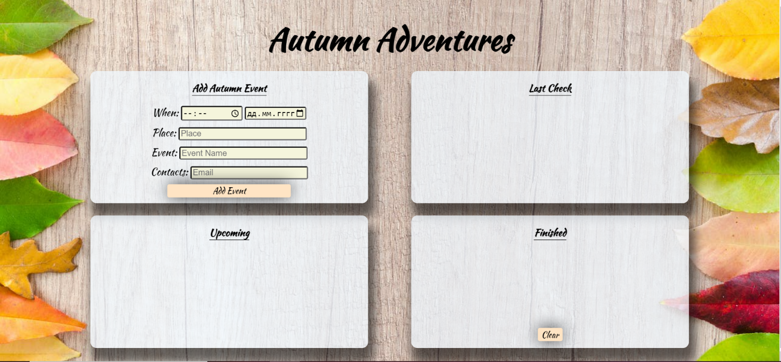**Write the missing functionality** of this user interface. The functionality is divided in the following steps:

## Your Task

**Write the missing JavaScript code** to make the **Autumn Adventures** work as expected:

All fields **(Time, Date, Place, Event,** and **Contacts)** are **filled with the correct input**

* **Time, Date, Place, Event,** and **Contacts** are **non**-**empty** **strings**. If any of them is empty, the program should not do anything.

## Gettining the Information from the form

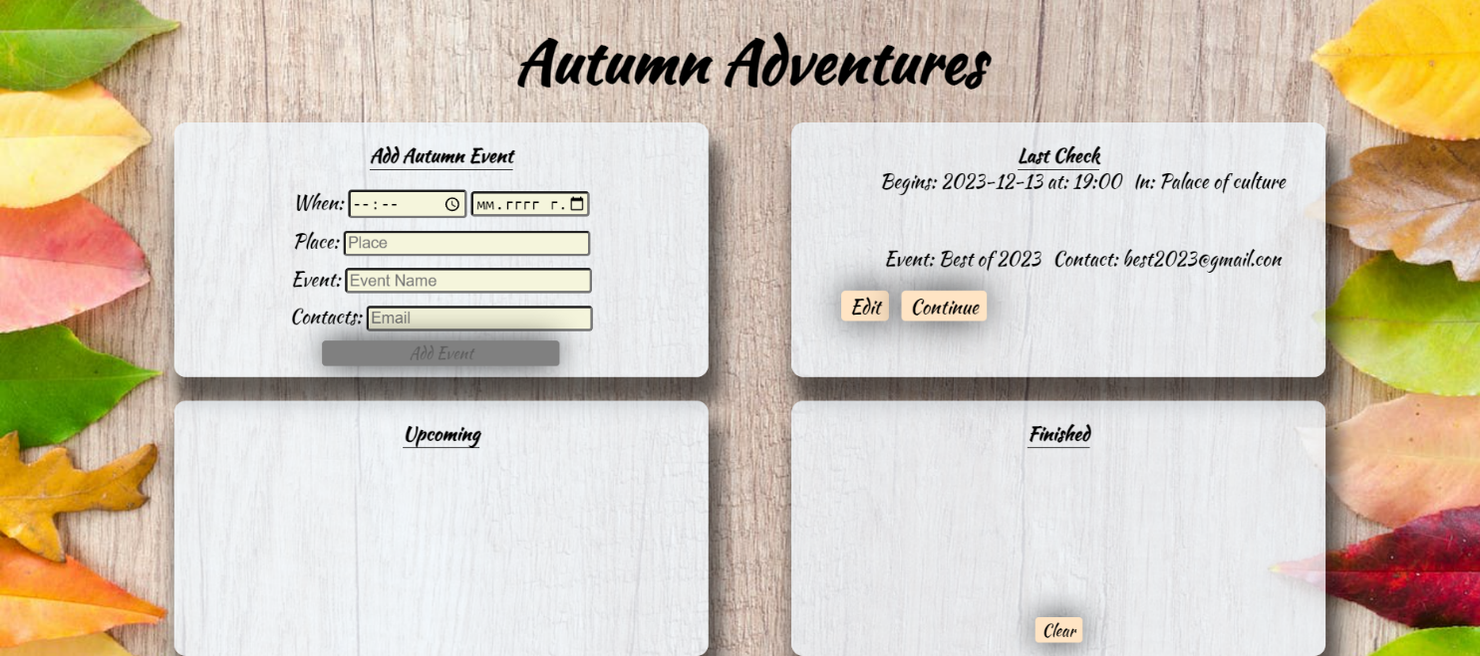

• When the **["Add Event"]** button is clicked, the information from the input fields is listed in the "**Last Check**" section. A **list item** is added to the **"check-list"** unordered list.

* The list item should follow the same text format and order as shown in the provided picture.
* When the button is clicked, the **input** fields must be **cleared**, and the **["Add Event"]** button should be **disabled**. Additionally, the **"Edit"** and **"Continue"** buttons need to be added.

The HTML structure looks like this:

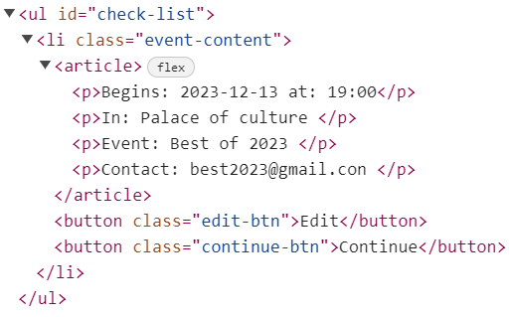

## Edit Event

**The functionality here is the following:**

* **When the "**Edit" **button is clicked, all of the information is loaded in to the input fields from step 1 and all the buttons in Last Check section are removed while the** ["Add Event"] **button is enabled again.**

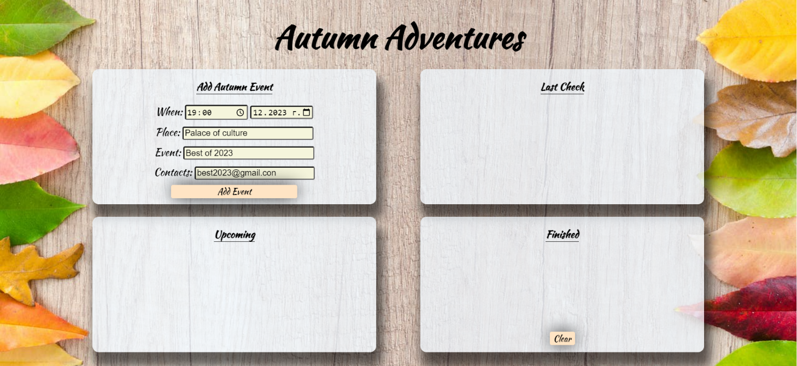

* **The list items must be removed from the** "check-list"



## Continue

* **When the** "Continue" **button is clicked,** **the information from** "check-list" unordered list must be transferred to "upcoming-list" in the same HTML structure**. For you, this means removing everything inside of the <ul> with class =** "check-list" **and adding in** " upcoming-list", **the list item with same information** The "Move to Finished" buttons must be **added while the** ["Add Event"] **button is enabled again.**

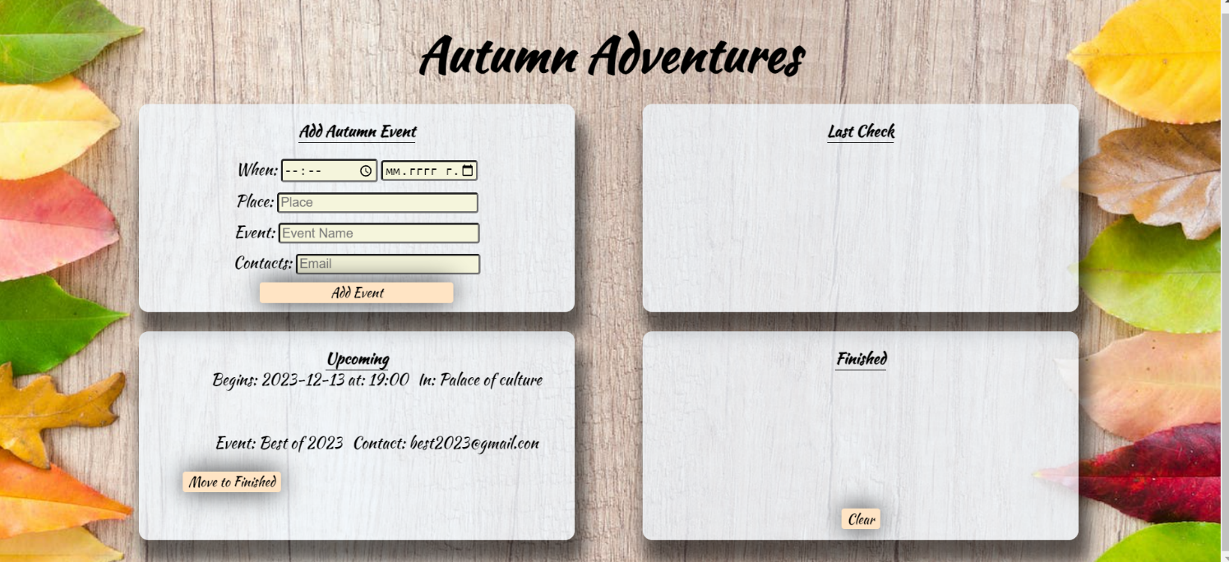

* **This is the HTML** structure **of the** "upcoming-list" unordered list**:**

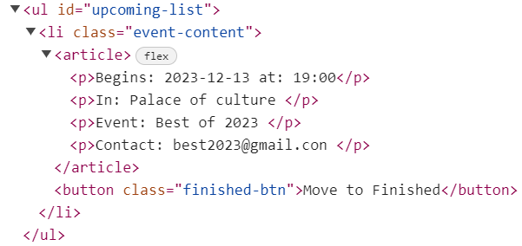

## Move to Finished

* **When the** "Move to Finished" **button is clicked,** **the information from the** "upcoming-list" unordered list must be transferred to "finished-list" in the same HTML structure**. For you, this means removing everything inside of the <ul> with class =** "upcoming-list" **and adding in to**"finished-list", **the list item with same information. The "Move to Finished” button must be removed.** 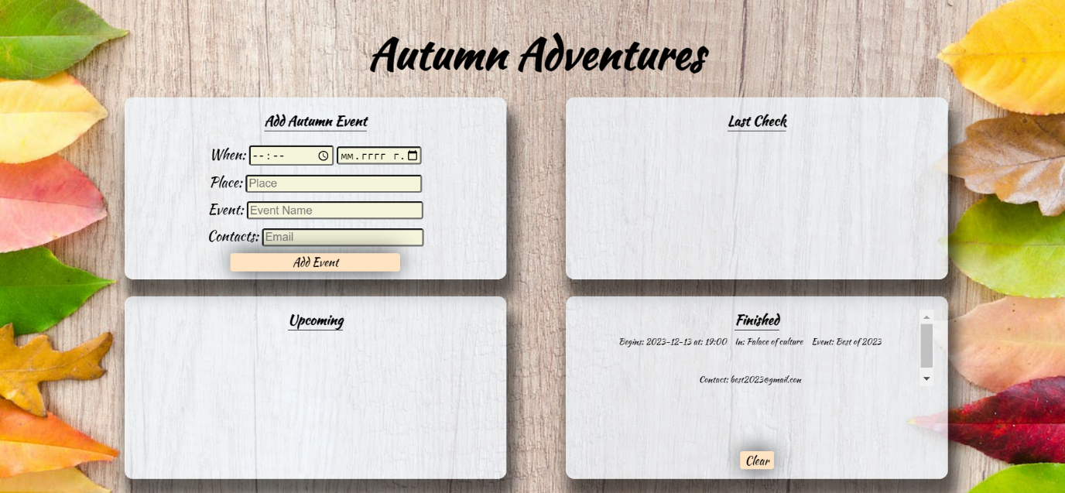

## Clear

* **When the** "Clear" **button is clicked,** **the list item must be removed, from the** "finished-list".
* "Clear" button:

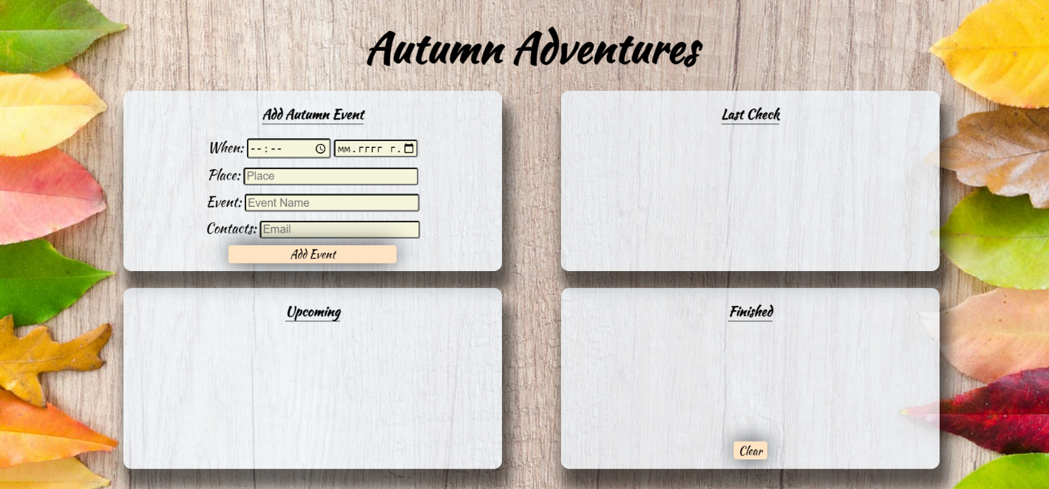

Submit only yours **solve()** function.

# Problem 2.Fashion Retail Management

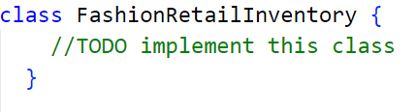

In the dynamic world of fashion retail, efficiently managing inventory is pivotal for catering to the ever-evolving demands of customers who seek clothing, shoes, and accessories. To meet these demands, you need to design a **class** named "**FashionRetailInventory** with updated functionality tailored to this specialized environment.

## Functionality

**Constructor**

Should have these **3** properties:

* **storehouse (string);**
* **location (string);**
* **productStock (empty array);**

**At the initialization** of the **FashionRetailInventory** **class**, the **constructor** accepts the **storehouse** and **location.**

### addProduct (productName, size, quantity, price)

This method adds a fashion product to the store's inventory. The method accepts four arguments:

* **productName (string);**
* **size (string);**
* **quantity (number);**
* **price (number);**
* If a product with the same name and size already exists in the **productStock**, add the quantity to the product and **return** the following message:

**`You added ${quantity} more pieces of product ${productName}** **size ${size}`**

* Otherwise, **add** the product with properties: **{productName, size, quantity, price}** to the **productStock** and **return** the following message:

**`The product ${productName}, size ${size} was successfully added to the inventory`**

### sendProduct (productName, size)

This method allows the sending of a product from the store's inventory. The method accepts two arguments:

* **productName (string)**;
* **size (string);**
* If the product with the given name and size is not present in the **productStock**, **throw** an **error** with the following message:

**`The product ${productName}, size ${size} is not in the inventory`**

* Otherwise, remove the product from the **productStock** and **return** the following message:

**`The product ${productName}, size ${size} was successfully removed from the inventory`**

### findProductsBySize(size)

The method accepts one arguments:

* **size (string);**
* Iterate through the **productStock** array and find all products that match the specified size and **return** a list of the products that match the given size in the format:

**`${product1}-${quantity} pieces, ${product2}-${quantity} pieces,…`**

* If no products matching the specified size are found in the **productStock**, **return:**

**`There are no products available in that size`**

### listProducts ()

* If there are no products in stock, **return**:

**`${storehouse} storehouse is empty`**

* Otherwise, on the first line **return**:

**`${storehouse} storehouse in ${location} available products:`**

* On the next lines, display information about each **product, sorted** in **alphabetical** order by their **productName** in the following format:

**`${productName}/Size:${size}/Quantity:${quantity}/Price:${price}$`**

## Examples

|  |
| --- |
| **Input 1** |
| const storeHouse = new FashionRetailInventory("East", "Milano");    console.log(storeHouse.addProduct("Shirt", "M", 10, 25.0));    console.log(storeHouse.addProduct("T-Shirt", "M", 10, 25.0));    console.log(storeHouse.addProduct("Sweather", "M", 10, 25.0));    console.log(storeHouse.addProduct("Sweather", "M", 10, 25.0)); |

|  |
| --- |
| **Output 1** |
| The product Shirt, size M was successfully added to the inventory  The product T-Shirt, size M was successfully added to the inventory  The product Sweather, size M was successfully added to the inventory  You added 10 more pieces of product Sweather size M |

|  |
| --- |
| **Input 2** |
| const storeHouse = new FashionRetailInventory("East", "Milano");    console.log(storeHouse.addProduct("Shirt", "M", 10, 25.0));    console.log(storeHouse.addProduct("T-Shirt", "M", 10, 25.0));    console.log(storeHouse.sendProduct("T-Shirt", "M"));    console.log(storeHouse.sendProduct("Sweather", "M")); |

|  |
| --- |
| **Output 2** |
| The product Shirt, size M was successfully added to the inventory  The product T-Shirt, size M was successfully added to the inventory  The product T-Shirt, size M was successfully removed from the inventory  Uncaught Error Error: The product Sweather, size M is not in the inventory |

|  |
| --- |
| **Input 3** |
| const storeHouse = new FashionRetailInventory("East", "Milano");    console.log(storeHouse.addProduct("Shirt", "M", 10, 25.0));    console.log(storeHouse.addProduct("T-Shirt", "M", 10, 25.0));    console.log(storeHouse.findProductsBySize("M"));    console.log(storeHouse.findProductsBySize("XL")); |

|  |
| --- |
| **Output 3** |
| The product Shirt, size M was successfully added to the inventory  The product T-Shirt, size M was successfully added to the inventory  Shirt-10 pieces, T-Shirt-10 pieces  There are no products available in that size |

|  |
| --- |
| **Input 4** |
| const storeHouse = new FashionRetailInventory("East", "Milano");    console.log(storeHouse.addProduct("Shirt", "M", 10, 25.0));    console.log(storeHouse.addProduct("T-Shirt", "M", 10, 25.0));    console.log(storeHouse.addProduct("Shirt", "L", 5, 30.0));    console.log(storeHouse.addProduct("Shoes", "9", 8, 50.0));    console.log(storeHouse.sendProduct("Shoes", "9", 8, 50.0));    console.log(storeHouse.listProducts()); |

|  |
| --- |
| **Output 4** |
| The product Shirt, size M was successfully added to the inventory  The product T-Shirt, size M was successfully added to the inventory  The product Shirt, size L was successfully added to the inventory  The product Shoes, size 9 was successfully added to the inventory  The product Shoes, size 9 was successfully removed from the inventory  East storehouse in Milano available products:  Shirt/Size:M/Quantity:10/Price:25$  Shirt/Size:L/Quantity:5/Price:30$  T-Shirt/Size:M/Quantity:10/Price:25$ |

# Problem 3. Pet Adoption Agency

## Your Task

Write JavaScript unit tests using Mocha and Chai to test the functionality of an object named **petAdoptionAgency**. You may use the following code as a template:

|  |
| --- |
| describe(**"*Tests* …"**, **function**() {  describe(**"*TODO* …"**, **function**() {  ***it***(**"*TODO …*"**, **function**() {  *//* ***TODO:*** …  });  });  *//* ***TODO:*** …  }); |

The **petAdoptionAgency** object simulates an animal adoption agency and provides several functions for managing pet adoption:

* **isPetAvailable(pet, availableCount, vaccinated) -**  A function that accepts three parameters: a **string** that represents the type of pet, a **number that** indicates the quantity of available pets and a **boolean** that indicates whether the pets are vaccinated or not.
* If the **availableCount** is less than or equal to 0, it indicates that there are currently no pets of that specific type available for adoption at the agency.In this case, the function returns:

**`** **Sorry, there are no ${pet}(s) available for adoption at the agency.`**

* If the **availableCount** is greater than 0, the pet is available for adoption, and the function **returns** one of two messages based on the vaccinated parameter:
  + If vaccinated is **true**:

**`** **Great! We have ${availableCount} vaccinated ${pet}(s) available for adoption at the agency.`**

* + If vaccinated is **false**:

**`** **Great! We have ${availableCount} ${pet}(s) available for adoption, but they need vaccination.`**

* There is a need for validation of the input, the **pet** parameter should be a **string**, the **availableCount** parameter should be an **number** and **vaccinated** should be a **boolean**. In case of invalid parameters, the function should **throw an error**:

**"Invalid input"**

* **getRecommendedPets(petList, desiredTraits) -** A function that accepts two parameters: an **array of objects** that stores pet objects with properties "name" and "traits" and a **string** representing the desired traits in a pet.
* The function searches for pets in the **petList** that have traits matching the **desiredTraits** and **returns** a list of their names in the format:

**`Recommended pets with the desired traits (${desiredTraits}): ${pet name}, ${pet name}`**

If no matching pets are found, it **returns**:

**`Sorry, we currently have no recommended pets with the desired traits: ${desiredTraits}.`**

* You need to validate the input; if **petList** and **desiredTraits** are **not an** **array** anda **string**, the function should **throw an error:**

**"Invalid input"**

* **adoptPet(pet, adopterName)** -A function that accepts two parameters,both **strings.**
* The function **returns** a success message in the format:

**`Congratulations, ${adopterName}! You have adopted ${pet} from the agency. Enjoy your time with your new furry friend!`**

* It includes input validation: if **pet** is not a string or **adopterName** is not a string, it throws an error with the message:

**"Invalid input"**

## JS Code

To ease you in the process, you are provided with an implementation that meets all of the specification requirements for the **petAdoptionAgency** object:

|  |
| --- |
| petAdoptionAgency.js |
| const petAdoptionAgency = {      isPetAvailable(pet, availableCount, vaccinated) {        if (typeof pet !== "string" || typeof availableCount !== "number" ||typeof vaccinated !== "boolean") {          throw new Error("Invalid input");        }        if (availableCount <= 0) {          return `Sorry, there are no ${pet}(s) available for adoption at the agency.`;        } else {          if(vaccinated){              return `Great! We have ${availableCount} vaccinated ${pet}(s) available for adoption at the agency.`;          }else{              return `Great! We have ${availableCount} ${pet}(s) available for adoption, but they need vaccination.`;          }          }      },      getRecommendedPets(petList, desiredTraits) {        let recommendedPets = [];          if (!Array.isArray(petList) || typeof desiredTraits !== "string") {          throw new Error("Invalid input");        }          petList.forEach((pet) => {          if (pet.traits === desiredTraits) {            recommendedPets.push(pet.name);          }        });          if (recommendedPets.length === 0) {          return `Sorry, we currently have no recommended pets with the desired traits: ${desiredTraits}.`;        } else {          return `Recommended pets with the desired traits (${desiredTraits}): ${recommendedPets.join(", ")}`;        }      },      adoptPet(pet, adopterName) {        if (typeof pet !== "string" || typeof adopterName !== "string") {          throw new Error("Invalid input");        }          return `Congratulations, ${adopterName}! You have adopted ${pet} from the agency. Enjoy your time with your new furry friend!`;      },    }; |

## Submission

Submit your tests inside a **describe()** statement, as shown above.